**NAAN MUDHALVAN PROJECT**

|  |  |
| --- | --- |
| **NAME** | SIVANANDHINI.S |
| **NM ID** | BC85F20CCAEC878B36C402DEAE255EA8 |
| **DEPARTMENT** | B.E-BIOMEDICAL ENGINEERING |
| **NM COURSE** | DIGITAL MARKETING |
| **COLLEGE** | DHANALAKSHMI SRINIVASAN INSTITUTE OF TECHNOLOGY |
| **TEAM ID** | NM2023TMID01885 |
| **TEAM MEMBERS** | PRIYADHARSHINI.K  SIVANANDHINI.S  VINDHIYA.L  VINISHA.P |

**PROJECT DESCRIPTION:**

A Google Business Page is a free online profile for businesses that appears on Google Search and Google Maps. It provides important information about your business, such as your name, address, phone number, website, hours of operation, and more. This page also allows customers to leave reviews, ask questions, and see photos of your business. Creating and managing a Google Business Page is essential for local businesses to improve their online visibility and connect with potential customers.

**BRAND NAME:**bellyblissbistro

**CATEGORY:** Food court(Restaurant)

**BRAND DESCRIPTION:**

At BELLY BLISS BISTRO!!,we believe that great food is a symphony of taste, texture, and artistry. Our talented chefs draw inspiration from global cuisines to curate a menu that marries tradition with innovation. From sizzling steaks and fresh seafood to vegetarian delights and mouthwatering desserts, our dishes are a testament to culinary excellence.

combines flavors& inspiration from the Far East & the West to create what we think is the best! Home to the original flavors. we specialize in pizzas, as well as handmade appetizers, sandwiches, salads, and gluten friendly, vegetarian, & vegan selections. Feel free to indulge in a tiki drink or craft beer with our fantastic unique cuisine. Cheers!

**PROJECT DOCUMENTATION:**

**E-MAIL ID:** [bellyblissbistro@gmail.com](mailto:bellyblissbistro@gmail.com)

**PASSWORD:** vps@2023

**DEMO VIDEO LINK:** [**https://youtu.be/KswZ_l13rsI?si=4NGTv2Zs3_qnJQoz**](https://youtu.be/KswZ_l13rsI?si=4NGTv2Zs3_qnJQoz)

[**https://drive.google.com/file/d/1EL5-WNXQQWZsVhYNf5ElQyae9W-aVVgF/view?usp=drivesdk**](https://drive.google.com/file/d/1EL5-WNXQQWZsVhYNf5ElQyae9W-aVVgF/view?usp=drivesdk)

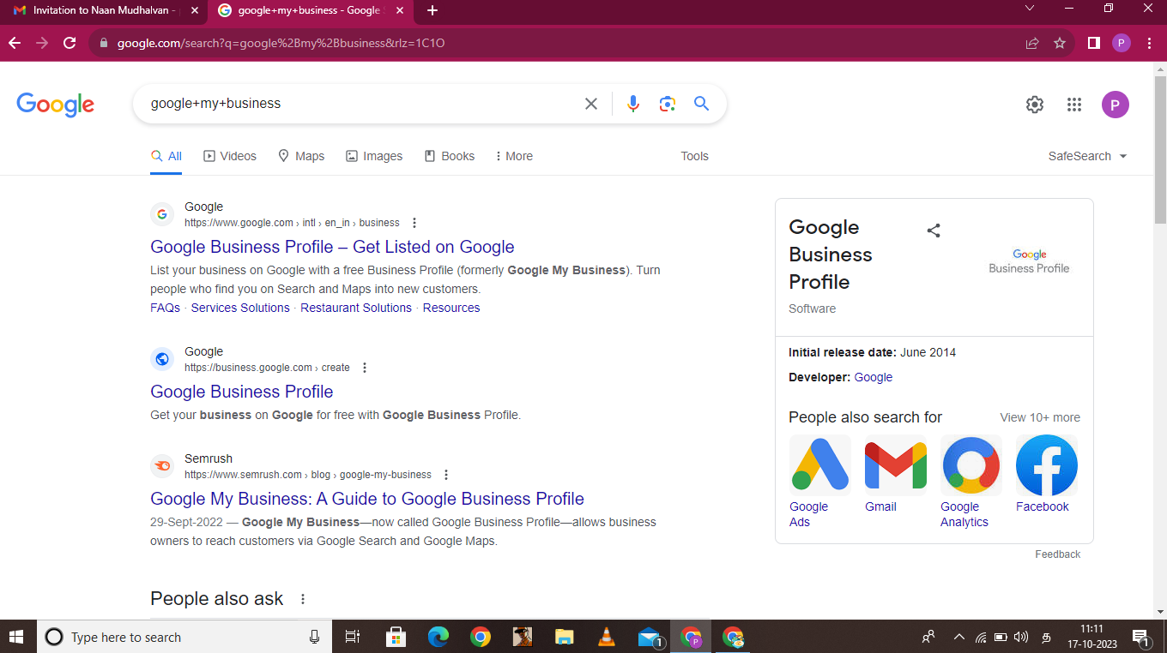**NAVIGATION:**

**SIGN IN:**

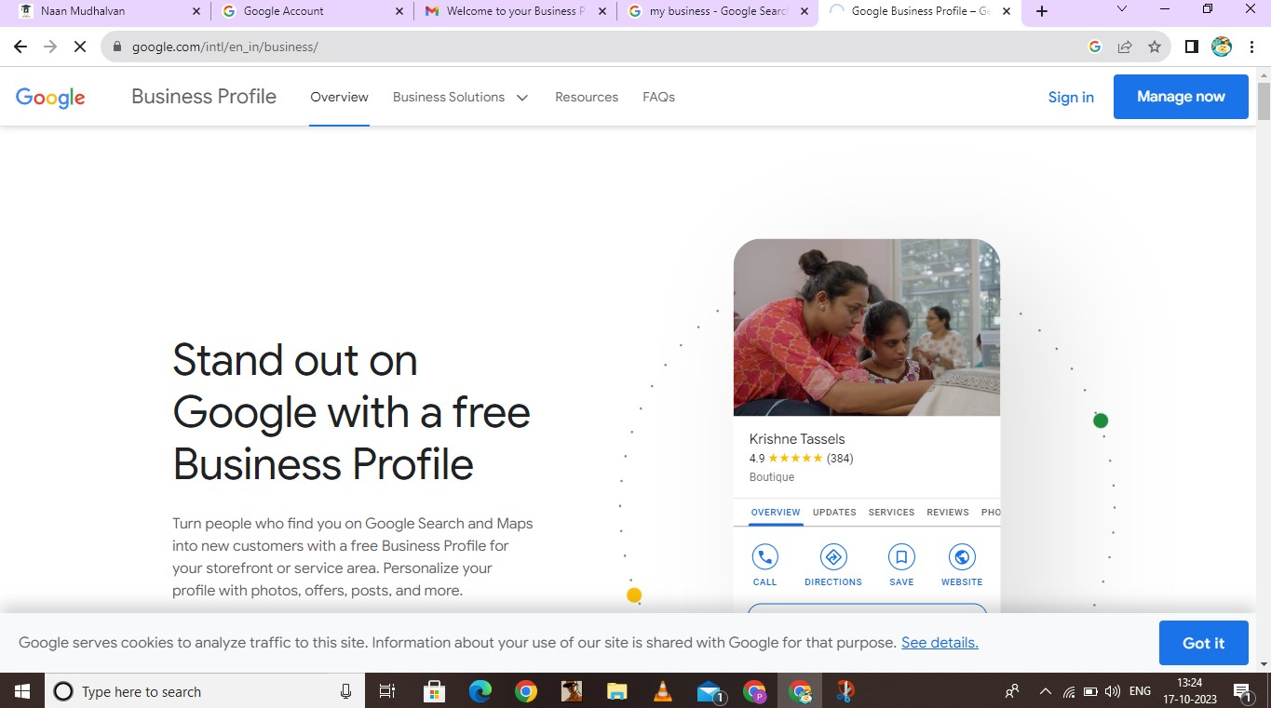

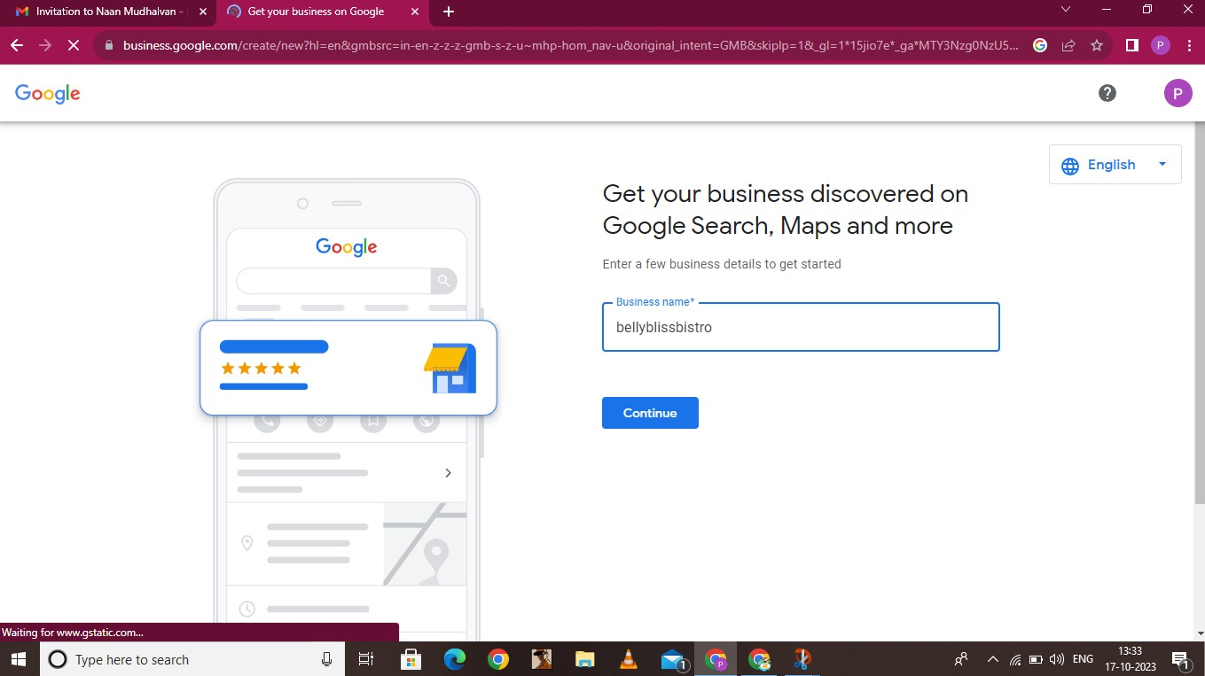**BUSINESS NAME:**

**BUSINESS TYPE & CATEGORY:**

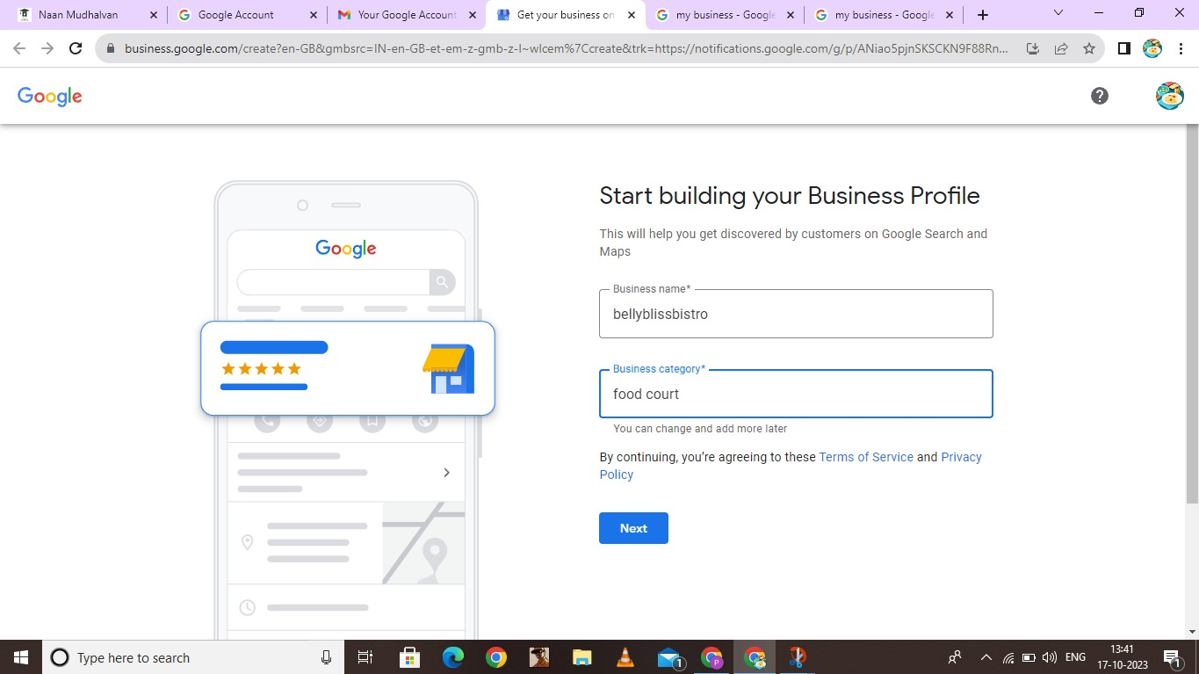

**BUSINESS ADDRESS:**

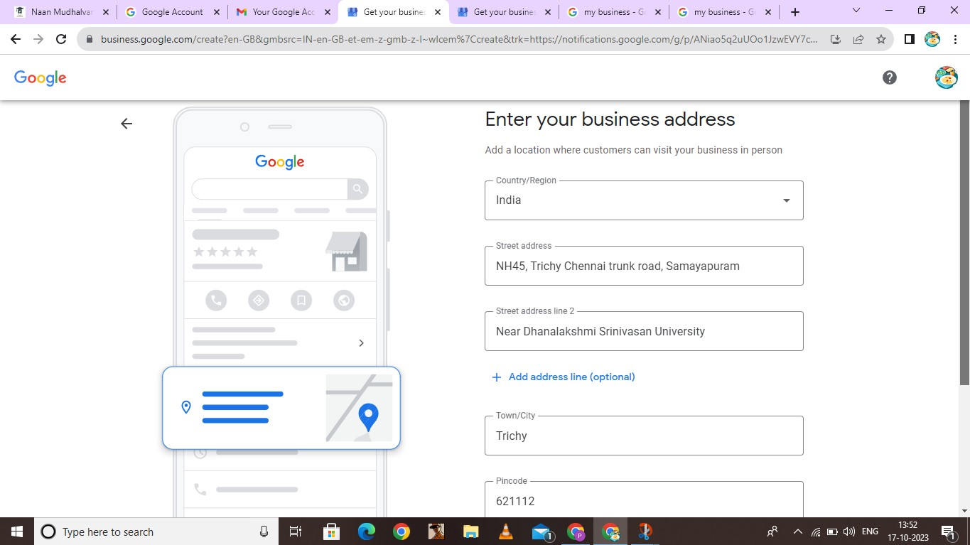

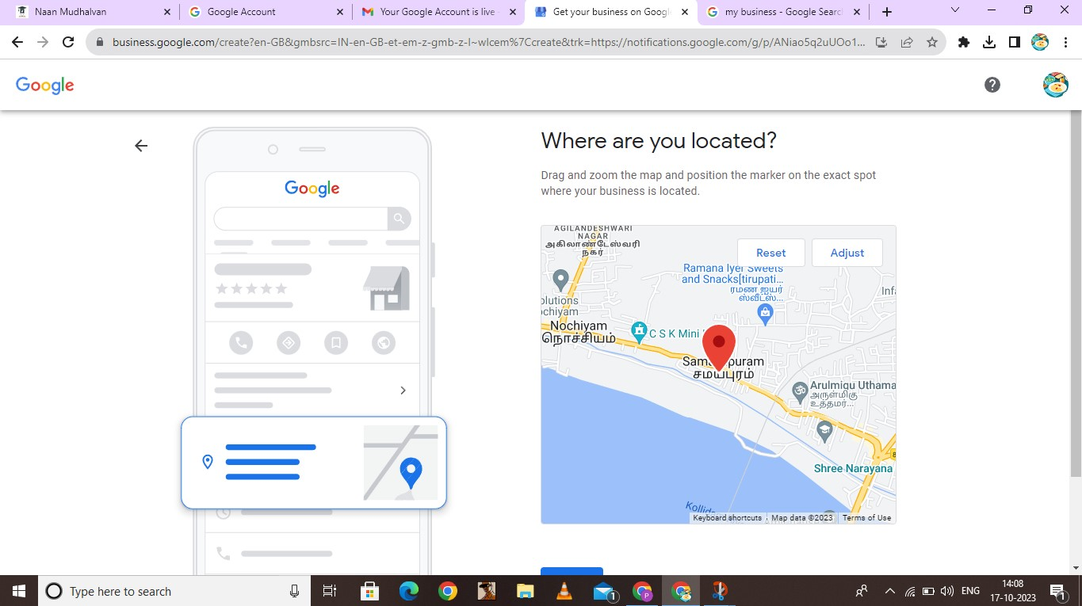**CHECKING BUSINESS LOCATION:**

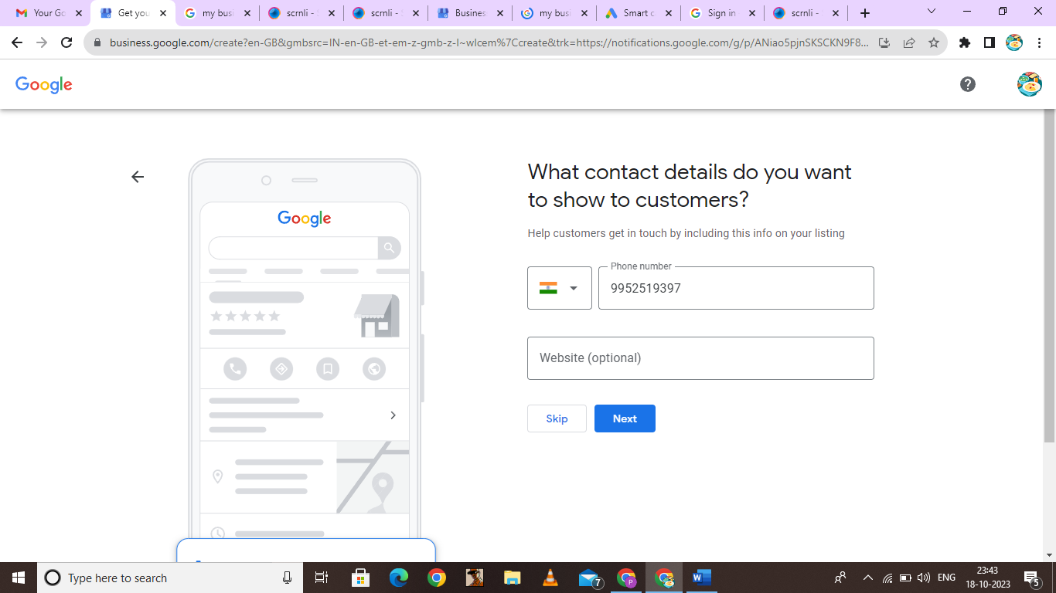**CONTACT DETAILS:**

**VERIFICATION:**

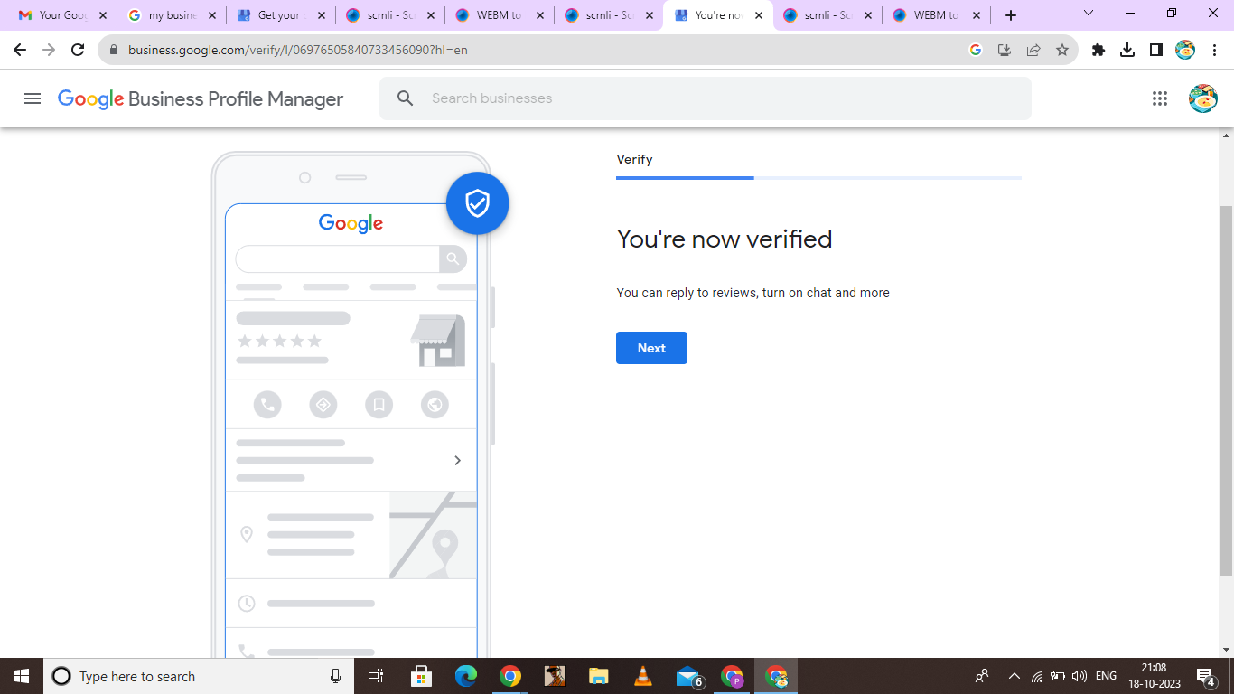

**BUSINESS HOURS:**

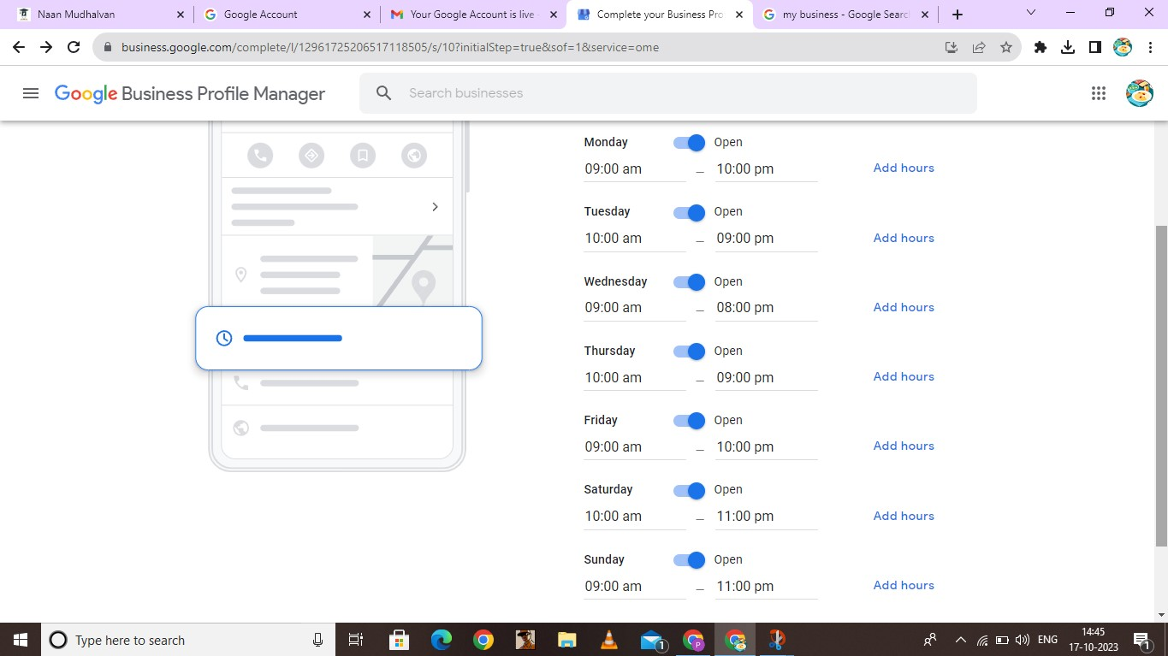

**BUSINESS DESCRIPTION:**

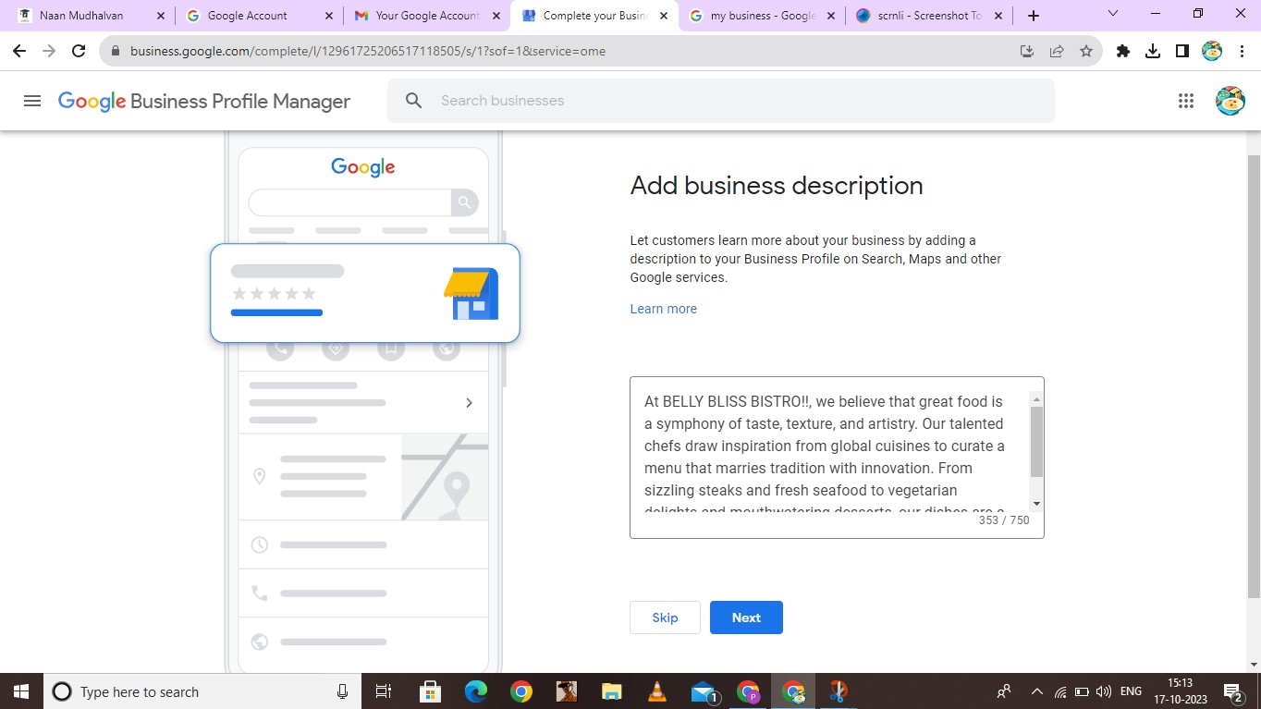

**UPLOAD PHOTOS:**

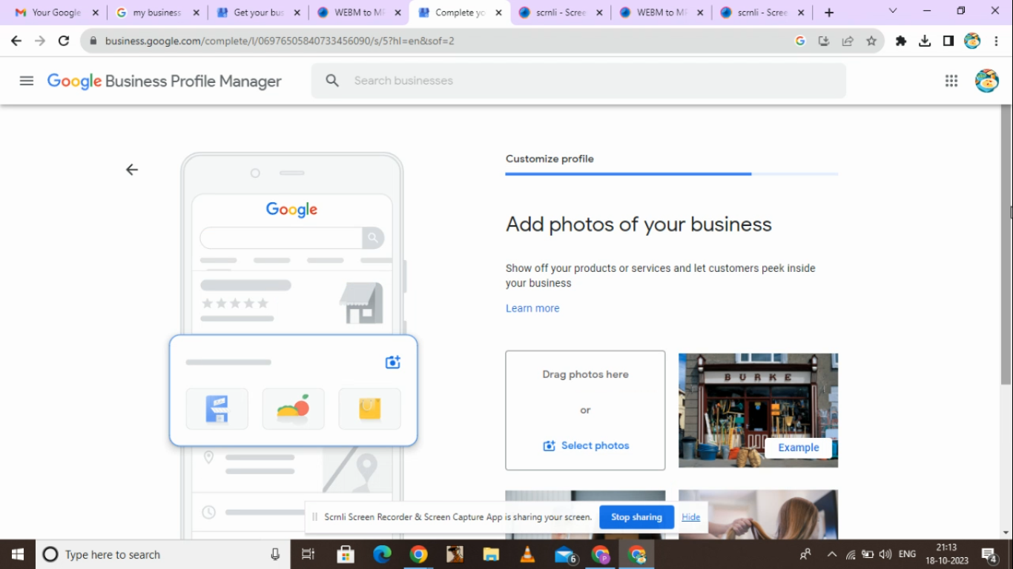

**CLAIMING BUSINESS:**

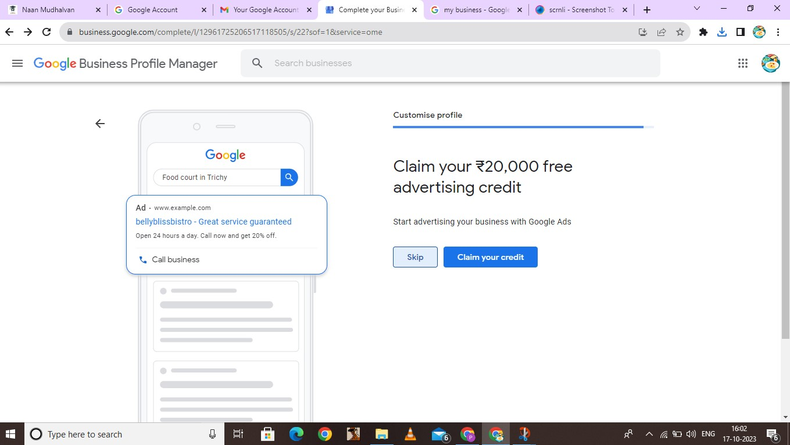

**VISIBILITY:**

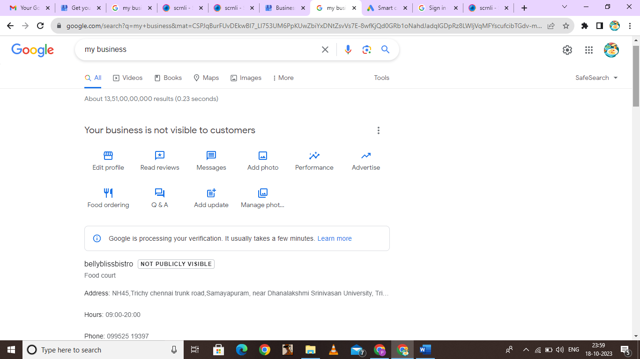

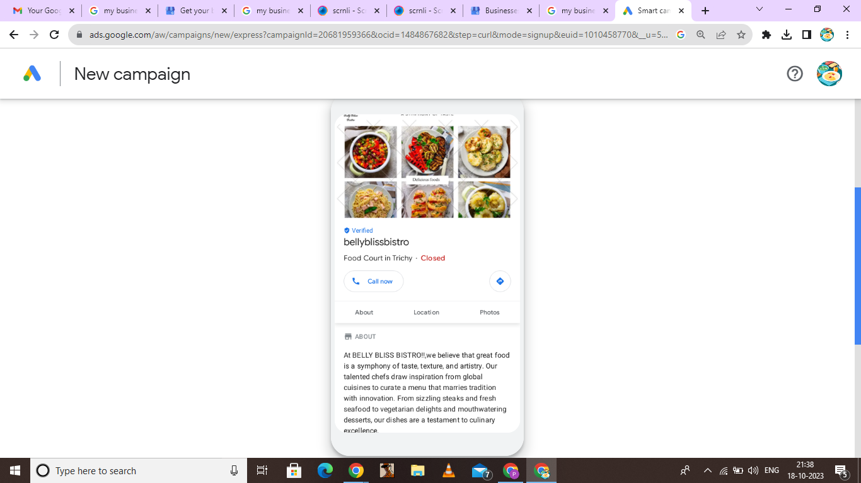**GOOGLE BUSINESS PROFILE:**